[Your Name]
[Instructor Name]
[Course Number]
[Date]

Renewable Resources: Solar Energy
Introduction
The sun, being our only source of solar energy, is a fusion reactor that has continued to burn for 4 billion years (Kalogirou). The sun has enough solar energy to meet our energy requirements within just minutes. It has been estimated that in a day the sun presents more energy than the current civilization can consume in 27 years (Lewis). Solar energy is one of the cheapest forms of energy that is naturally available to u for free. The only cost we get to incur is that of developing the necessary tools to capture the energy.
Solar energy is produced when sunlight comes into direct contact with solar panels. The solar panel turns the solar power into usable electricity through chemical reactions that involves the photovoltaic transformation (Bing).
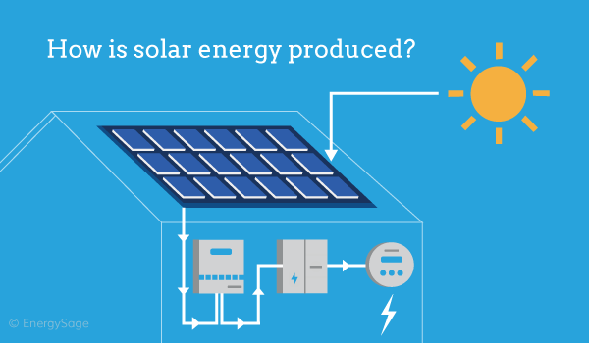

History of Solar Energy
The idea of benefiting from solar energy is relatively new. The first thermal solar collector was founded by a Swiss scientist by the name Horace de Saussure, in 1767 (Jones). With the advancement in technology, it then becomes possible to use the energy for heating and cooking. The first commercial patent of the solar heater equipment was by Clarence Kemp in 1891, which was purchased by California executives who accelerated the use of the system. Until 1897, more than one-third of the houses in Pasadena were already equipped with solar heaters (Jones). Edmund Becquerel, French scientists realized that could produce a photovoltaic effect, which led to the development of Selenium photovoltaic(PV) cells. PV cells have the ability to convert light into electricity.

Cost of Solar energy
Sunlight is abundant and can be found for free, but the technology required to tap this potential is expensive. To reduce the cost countries have come up with policies that would reduce the burden of purchasing the required equipment. Currently, there are more than 130 countries that have policies that lower the installation of solar panels. Due to these policies, the International Energy Agency (IEA) calculated the cost of solar energy and found out that it fell below 20 to 50 percent in 2020 compared to 2019. The IEA states that prices continue to fall and solar energy is expected to dominate the market over the coming decade. With the urgent need to tackle climate change more and more policies are being placed that are in favor of solar energy.

Usage
Solar energy can be effective in increasing productivity; this is especially useful in the agricultural sector. In the agricultural area, it is important to improve natural resource management. This implies that there should be high yields, faster production, and lower losses. Only through solar energy is such attainable. In the area of agriculture solar panel is useful in irrigation, refrigeration of agricultural products, electric fencing, pest control, cattle drinking, and dozens of other applications (Elsheikh). However, solar energy here is only useful in activities that require little power usage and other alternatives have to be found for energy-intensive activities such as operating rice mills.

Dangers
Over the years, solar energy has been sold to the public as natural, clean, and inexhaustible. However, this is not the case as the systems are prone to electrical failures that could result in loss of property or even death (Mironov). Additionally, solar collector panels are made of systems that can fail and need replacement with new elements. Leaving such components unchanged may result in damage including fires caused by electric shocks.
The manufacturing of solar panels generates many toxic by-products. The manufacturing of solar panels requires chemical materials such as cadmium and arsenic, the process generates by-products such as sulfur and silicon tetrachloride (Mironov). Such products are dangerous to both the environment and living things.

Economic Factors
According to the Energy Information Administration(EIA) solar electricity is currently pricey. It is the most expensive form of electricity among current technology for renewable electricity generation, for PV EIA estimates it to be $396 per megawatt hour. This is more than double of the total system leveled cost of almost four times the coast of coal (Nixon). Although this is the coast for large-scale solar production the costs are also felt on small installations. This is because they cannot take advantage of buying or installing in bulk.
The diagram illustrates the cost of solar energy compared to other alternatives.

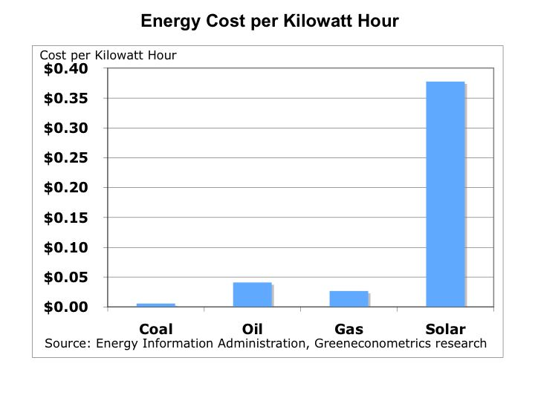

Consumption and usage
Solar energy in the United States includes locally distributed power that mostly comprises of rooftops photovoltaics and large scale solar energy plants. It has been estimated that by 2017 the country had already installed a PV capacity of over 50 Gigawatts and the large-scale utility solar energy had produced 66.6 terawatt-hours by 2018. This translated to 1.66% of the total energy consumption in the United States (Crestanello).
China has been the leading installer of PV since 2013 after passing Germany to cross the 100 Gigawatt line in 2017 (Crestanello). Other countries such as India and Japan are also joining the journey to green energy using solar panels as illustrated below. 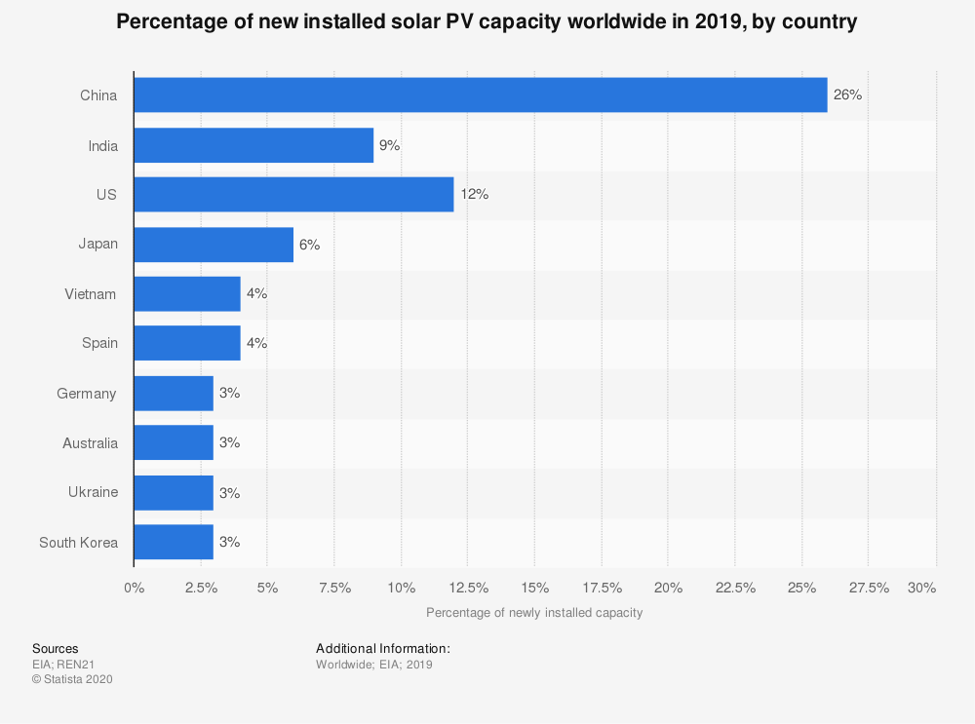

Pros and Cons
Among the benefits of using solar energy is that it is one of the most “truly renewable” energy sources. It is easily harnessed in all areas of the world and is impossible to run out of. The sun is always available to us and will be in the next generation hence it is a reliable source of energy to invest in. Being available for free also implies that it will help in reducing electric bills to most households if not helping them earn extra though feeding electricity harvested back to the grid. Solar energy can be used for diverse purposes such as producing electricity in the area without access to electricity and in extreme situations such as providing power to satellites in space, to distilling water in regions that lack clean water.
On the other hand, the grass isn’t always greener with solar energy. The initial cost is fairly high and people who want to own solar panels have to wait and have hopes that the technology will improve and lower the cost. Another concern is that it is weather dependent, and a few rainy days can have negative effects on the power system. With this also comes the burden of storage and its costs. For most homesteads, they have to be connected to the grid and cannot entirely depend on their solar panels. The planes also consume a lot of space and size might be a limiting factor to the amount of sunlight that can be collected. Lastly, the pollution associated with the installation and transportation causes concerns although it pollutes far less than the other alternative energy sources.

Conclusion
PVs are one of the most important innovations for our civilization. this is because the current rate of environmental pollution caused by our energy consumption using coal raises a great deal of concern for our future generations. Governments have realized this and the policies such as the ones placed in Japan that have helped cross great lines in solar power production are actions to correct our current situations. None the less, gas and coal are exhaustible and we will be forced to look for other alternatives. Investing in solar energy is our best bet, and the cheapest way available with the increase in innovation.it is therefore important that we put all our efforts into developing ways to tap solar energy, despite its setbacks, since it is the only choice that is viable for us to produce electricity cheaply on a large scale.

Work Cited

"Data & Statistics - IEA". IEA, 2020, https://www.iea.org/data-and-statistics?country=WORLD&fuel=Energy%20supply&indicator=TPESbySource.
Bing, James M. "Method and system for predicting solar energy production." U.S. Patent No. 7,580,817. 25 Aug. 2009
Crestanello, Juan Pedro. "The Impact of Renewable Electricity Production on Carbon Emissions." (2020)
Elsheikh, Ammar H., et al. "Modeling of solar energy systems using artificial neural network: A comprehensive review." Solar Energy 180 (2019): 622-639
Jones, Geoffrey G., and Loubna Bouamane. "" Power from Sunshine": A Business History of Solar Energy." Harvard Business School Working Paper Series (2012)
Kalogirou, Soteris A. Solar energy engineering: processes and systems. Academic Press, 2013
Lewis, Nathan S. "Toward cost-effective solar energy use." science 315.5813 (2007): 798-801
Mironov, Victor, et al. "Technology of receiving fresh water from forcedly saturated air through the use of solar energy." E3S Web of Conferences. Vol. 91. EDP Sciences, 2019
Nixon, Bronte, and W. S. P. Planner. "EIA Consistency and the Potential Micro-Climate Impact of Solar Farms IAIA 2019."

